Sensor coordinates (center of the bottom face)

IMU : X=0 Y=140mm Z=26mm

LIDAR : X=0 Y=0 Z=176mm

Right wheel : X=81.5 Y=-87.5mm Z=37.8mm

Left Wheel : X=-81.4 Y=-87.5mm Z=37.8mm 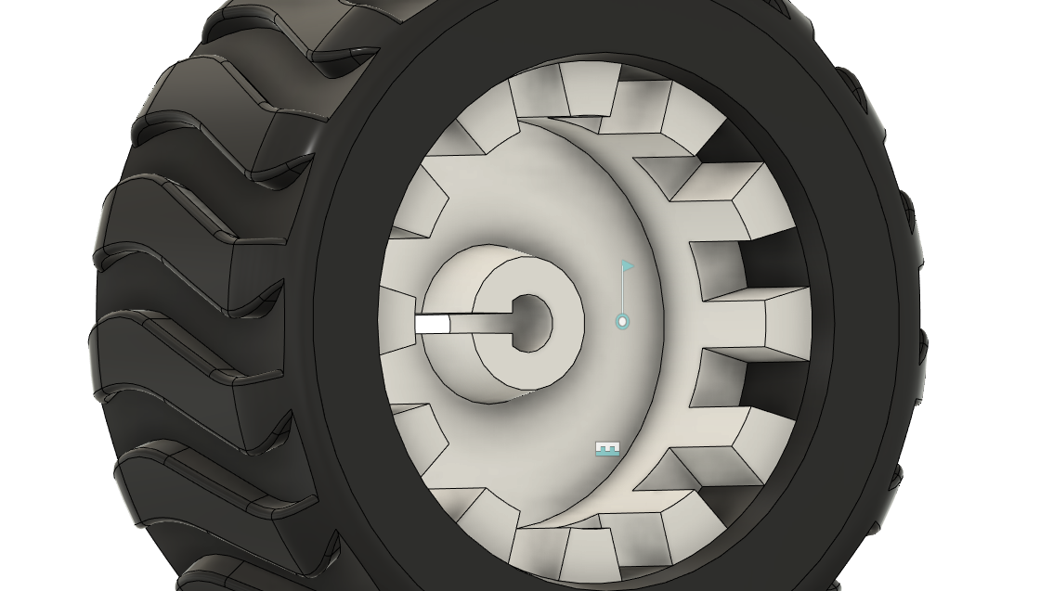Left wheel in figure

Coordinates are of the center of face of the hole in figure

This is the inner side of the wheel, facing the motor

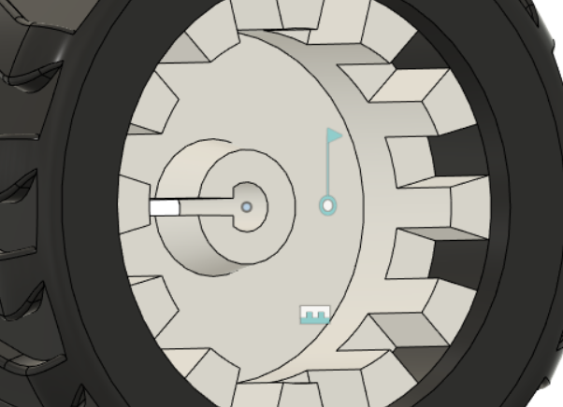

Point in reference